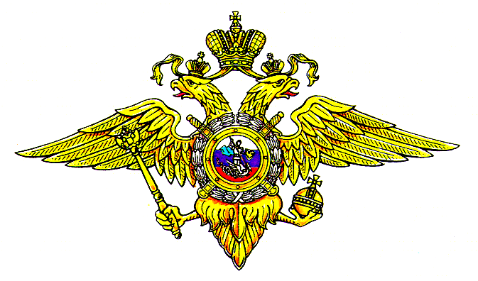

**Утверждаю**

Начальник ФПСОИБ

Московского университета

МВД России им. В.Я. Кикотя

подполковник полиции

А.С. Эрдниев

«__»_______________2023 г.

**График**

несения нарядов курсантами 903 взвода 3 «И» курса

ФПСОИБ МосУ МВД России на **июнь** 2023 года

|  |  |  |  |  |  |  |  |  |  |  |  |  |  |  |  |  |  |  |  |  |  |  |  |  |  |  |  |  |  |  |  |  |  |  |  |  |  |  |  |  |  |  |  |  |  |  |  |  |  |  |  |  |  |  |  |  |  |
| --- | --- | --- | --- | --- | --- | --- | --- | --- | --- | --- | --- | --- | --- | --- | --- | --- | --- | --- | --- | --- | --- | --- | --- | --- | --- | --- | --- | --- | --- | --- | --- | --- | --- | --- | --- | --- | --- | --- | --- | --- | --- | --- | --- | --- | --- | --- | --- | --- | --- | --- | --- | --- | --- | --- | --- | --- | --- |
| **№ п/п** | **Ф.И.О.** | **1** | | **2** | | **3** | | **4** | | **5** | | **6** | | **7** | | **8** | | **9** | | **10** | | **11** | | **12** | | **13** | | **14** | | **15** | | **16** | | **17** | | **18** | | **19** | | **20** | | **21** | | **22** | | **23** | | **24** | | **25** | | **26** | | **27** | **28** | **29** | **30** |
|  | Абдульманова А.А.АААА.О. |  | |  | |  | |  | |  | |  | |  | |  | |  | |  | |  | | **Н** | |  | |  | |  | |  | |  | |  | |  | |  | |  | |  | |  | |  | |  | |  | |  |  |  |  |
|  | Аушев И.Р. |  | |  | |  | |  | |  | |  | |  | |  | |  | |  | |  | |  | |  | |  | |  | |  | |  | |  | |  | |  | |  | |  | |  | |  | |  | |  | |  |  |  |  |
|  | Баранова А.А. |  | |  | |  | |  | | **Н** | |  | |  | |  | |  | |  | |  | |  | |  | |  | |  | |  | |  | |  | |  | |  | |  | |  | |  | |  | |  | |  | |  |  | **Н** |  |
|  | Бережной А.С. |  | | **пд** | |  | |  | |  | |  | |  | |  | |  | |  | |  | |  | |  | |  | |  | |  | |  | |  | |  | |  | |  | |  | |  | |  | |  | |  | |  |  |  |  |
|  | Глазков Г.А. |  | |  | |  | |  | |  | |  | |  | |  | |  | |  | |  | |  | |  | |  | |  | |  | |  | |  | |  | |  | | **пд** | |  | |  | |  | |  | |  | |  |  |  |  |
|  | Игнашева В.С. |  | |  | |  | |  | |  | |  | |  | |  | |  | |  | |  | |  | |  | |  | |  | |  | |  | |  | |  | |  | |  | |  | |  | |  | |  | |  | | **пд** |  |  |  |
|  | Комаров С.П. |  | |  | |  | |  | |  | |  | |  | |  | |  | | **Н** | |  | |  | |  | |  | |  | |  | |  | |  | |  | |  | |  | |  | |  | |  | |  | |  | |  |  |  |  |
|  | Кошкош Д.А. |  | |  | |  | |  | |  | |  | |  | |  | |  | |  | |  | |  | |  | |  | |  | |  | |  | |  | |  | |  | |  | |  | |  | |  | |  | |  | |  |  |  |  |
|  | Кумченко А.В. |  | |  | |  | |  | |  | |  | |  | | **Н** | |  | |  | |  | |  | |  | |  | | **Н** | |  | |  | |  | |  | |  | |  | |  | |  | |  | |  | |  | |  |  |  |  |
|  | Ломакина А.Д. |  | |  | |  | |  | | **Н** | |  | |  | |  | |  | |  | |  | |  | |  | |  | |  | |  | |  | |  | |  | |  | |  | |  | |  | |  | |  | |  | |  |  | **Н** |  |
|  | Люсов Д.Я. |  | |  | |  | |  | |  | |  | |  | |  | | **Н** | |  | |  | |  | |  | |  | |  | |  | |  | |  | |  | |  | |  | |  | |  | |  | |  | |  | |  |  |  |  |
|  | Руденко М.П. |  | |  | |  | |  | |  | |  | |  | |  | |  | |  | |  | |  | |  | |  | | **пд** | |  | |  | |  | |  | |  | |  | |  | |  | |  | |  | |  | |  |  |  |  |
|  | Собцов А.С. |  | |  | |  | |  | |  | |  | |  | |  | |  | | **Н** | |  | |  | |  | |  | |  | |  | |  | |  | |  | |  | |  | |  | |  | |  | |  | |  | |  | **Н** |  |  |
|  | Фастунов А.Д. |  | |  | |  | |  | |  | |  | |  | |  | |  | |  | |  | |  | |  | |  | |  | |  | |  | | **Н** | |  | |  | |  | |  | |  | |  | |  | |  | |  | **Н** |  |  |
|  | Филюшин Д.А. |  | |  | |  | |  | |  | |  | |  | |  | |  | |  | |  | |  | |  | |  | |  | |  | |  | |  | |  | |  | |  | |  | | **Н** | |  | |  | |  | |  |  |  |  |
|  | Чайкин Д.А. |  | |  | |  | |  | |  | | **Н** | |  | |  | |  | |  | |  | |  | |  | |  | |  | |  | | **Н** | |  | |  | |  | |  | |  | |  | |  | |  | |  | |  |  |  |  |
|  | Чернова А.В. |  | |  | |  | |  | |  | |  | |  | |  | |  | |  | |  | |  | |  | |  | |  | |  | |  | |  | |  | |  | |  | |  | |  | |  | |  | | **Н** | |  |  |  |  |
|  | Чозгиян А.С. |  | |  | |  | |  | |  | |  | |  | |  | |  | | **Н** | |  | |  | |  | |  | |  | |  | |  | |  | |  | |  | |  | |  | |  | |  | |  | |  | |  | **Н** |  |  |
|  | Чуйков А.П. |  | | **Н** | |  | |  | |  | |  | |  | |  | |  | |  | |  | |  | |  | |  | |  | |  | |  | |  | |  | |  | |  | |  | |  | |  | |  | |  | |  |  |  |  |
|  |  |  |  | |  | |  | |  | |  | |  | |  | |  | |  | |  | |  | |  | |  | |  | |  | |  | |  | |  | |  | |  | |  | |  | |  | |  | |  | |  | |  |  |  |

Примечания:

**К** – постовой по КПП

**П** – патрульный по объекту

**ПД** – помощник дежурного

**НХ** – наряд хозяйственный

**С** – наряд по столовой

**Н** – суточный наряд

Начальник 3 «И» курса ФПСОИБ  
МосУ МВД России имени В.Я. Кикотя  
подполковник полиции А.А. Артемов

«___» _________________ 2023 г.

**Красным выделено то, что должно меняться в зависимости от выборки.**

**А так документ берется под основу шаблона!**